Student Name: __________________
Class and Section __________________
Total Points (20 pts) __________________
Due: Feb 18, 2013 before the class

Project: Multiple Eight Queens Solution

CSCI 2210 Data Structures and Algorithms
Armstrong Atlantic State University

Problem Description:

(Game: multiple Eight Queens solution) Write an applet to display all possible solutions for the Eight Queens puzzle in a scroll pane, as shown in the following figure. For each solution, put a label to denote the solution number. Hint: Place all solution panels into one panel and place this one panel into a JScrollPane. The solution panel class should override the getPreferredSize() method to ensure that a solution panel is displayed properly. See Listing 15.3, FigurePanel.java, on how to override getPreferredSize().

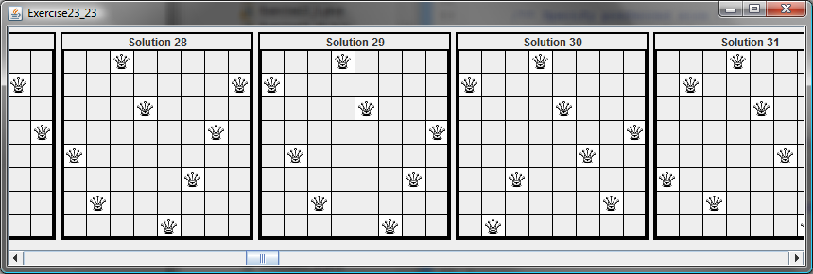

Copy Your Code here:
(Name the program Exercise22_23)

Screen shots:

What to submit?

1. Complete and submit the hardcopy of this document.

2. Compile and Submit to LiveLab (you must submit the program regardless whether it is complete or incomplete, correct or incorrect)

3. Fill in self-evaluation:

- Can your program display all solutions?
- Can your program find all solutions correctly?

